**Summary**

|  |  |  |  |  |  |  |
| --- | --- | --- | --- | --- | --- | --- |
|  | Breeding bird atlas | Density estimates | Scarce breeding bird counts | Point counts | Index timeseries | HILDA land use |
| *Temporal* | 1974-2017 | 2017 | 2017 | 1976-2020 | 1976-2020 | 1900-2010 |
| *Resolution* | 1974,1996,2014;  Breeding season | Breeding / winter season | Breeding season | Yearly;  Breeding/winter season | Yearly; Breeding/winter season | Decadal |
| *Spatial* | Denmark, lattice | Denmark,  lattice | Denmark,  lattice | Denmark | - | Europe, lattice |
| *Resolution* | 5kmx5km | 1kmx1km | 5kmx5km | Selected routes | - | 1kmx1km |
| *Thematic* | Breeding birds | Common breeding birds | 18 scarce breeding birds | Breeding and wintering birds | (common) breeding and wintering birds | 6 land-use types |
| Description | Confirmed, probable or possible breeding in each grid cell, nationwide, for all breeding birds at three distinct timesteps | Estimated densities in each grid cell, nationwide, for common breeding birds in breeding and winter season | Population counts of confirmed, probable or possible breeding in each grid cell, nationwide, for 18 preselected scarce breeding birds | Species counts in routes repeated yearly in both breeding and winter seasons | Yearly timeseries of relative abundance based on point counts in both breeding and winter seasons | Reconstruction of landuse in Europe in the 20th century at decadal timesteps, covering 6 land use types |
| Data acquired by Wes? | No | No | No | Yes | Yes | Yes |

**Breeding Bird Atlas I, II, III**

*Temporal*: 1971-1974, 1993-1996, 2014-2017 *Resolution*: 3 repeats

*Spatial*: Denmark, lattice *Resolution:* 5kmx5km

*Thematic*: Breeding birds

*Data type:* presence in grid cell (confirmed, probable, possible)

*Description:* Birdlife Denmark’s breeding bird atlas I,II,III represent high quality nation-wide atlas data across the entirety of Denmark. This data resembles occurrences of all breeding birds in Denmark at three different moments, with equal intervals, from the 1970s to the 2010s. The methods have been kept almost consistent throughout the three different atlases, allowing for comparisons between the three.

The atlas projects took place at three distinct timesteps, each over a few years. Final distribution maps represent all information received from all squares during the entire 4-year period; it does not represent yearly information *within* these timesteps.

Breeding bird occurrences are classified as confirmed, probable or possible. Classification depends on some species-specific checks (e.g. concrete breeding finds like nests, breeding behaviour in a suitable biotope, timing of behaviour) and some guidelines (see next page). Classifications are determined by observers (Atlas I and II) or by an algorithm (Atlas III).

Over time, the grid-cells have remained almost entirely the same, with some grid cells being added for Atlas III.

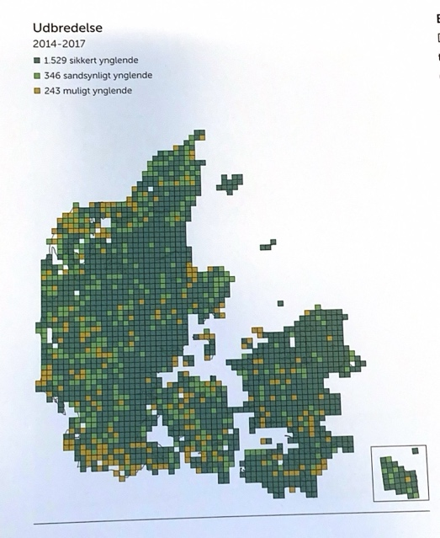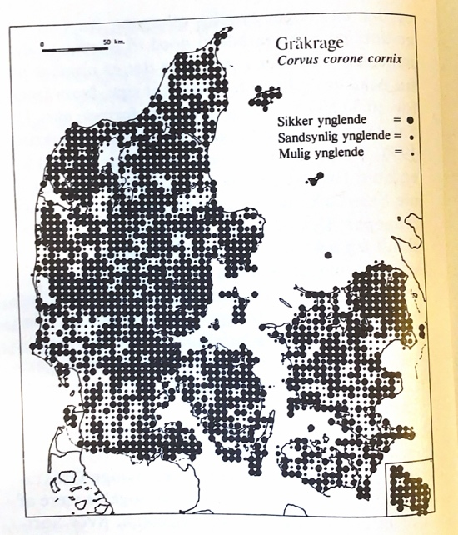

Fig 1: Atlas data for hooded crow in Atlas I (left) and Atlas III (right)

**Possible breeding:**

1. Bird seen during the breeding season in a possible breeding biotope without any sign of breeding elsewhere

**Probable breeding:**

1. Singing male heard during breeding season
2. Bird or pair claiming territory
3. Mating behaviour
4. Anxious call of mature birds, likely indicating nests or young nearby
5. Nest-building birds

**Confirmed breeding:**

1. distinct distraction/diversionary behaviour
2. freshly used nests from the same year found
3. mature birds that carry excrement bags in their beaks
4. mature birds with food for young
5. mature birds flying to or from the nest under circumstances that suggest the nest is occupied
6. nest with eggs, or fresh eggshells found in immediate vicinity of the nest
7. nest with young, or young of ducks, hens, waders etc.

**Nationwide density estimates common birds (spatial densities)**

*Temporal*: 2014-2017 *Resolution;* summer and winter

*Spatial*: Denmark, lattice *Resolution*: 1kmx1km

*Thematic*: Common bird species across the country

*Data type:* density / km2

*Description:* population densities were estimated for a set of pre-selected common birds. These data represent an estimate of number of individuals per km2. Densities are estimates using distance sampling; counted numbers of individuals are extrapolated to nation-wide (population) estimates using species-specific detection rates. Spatial patterns of densities are available in both the breeding season and in winter.

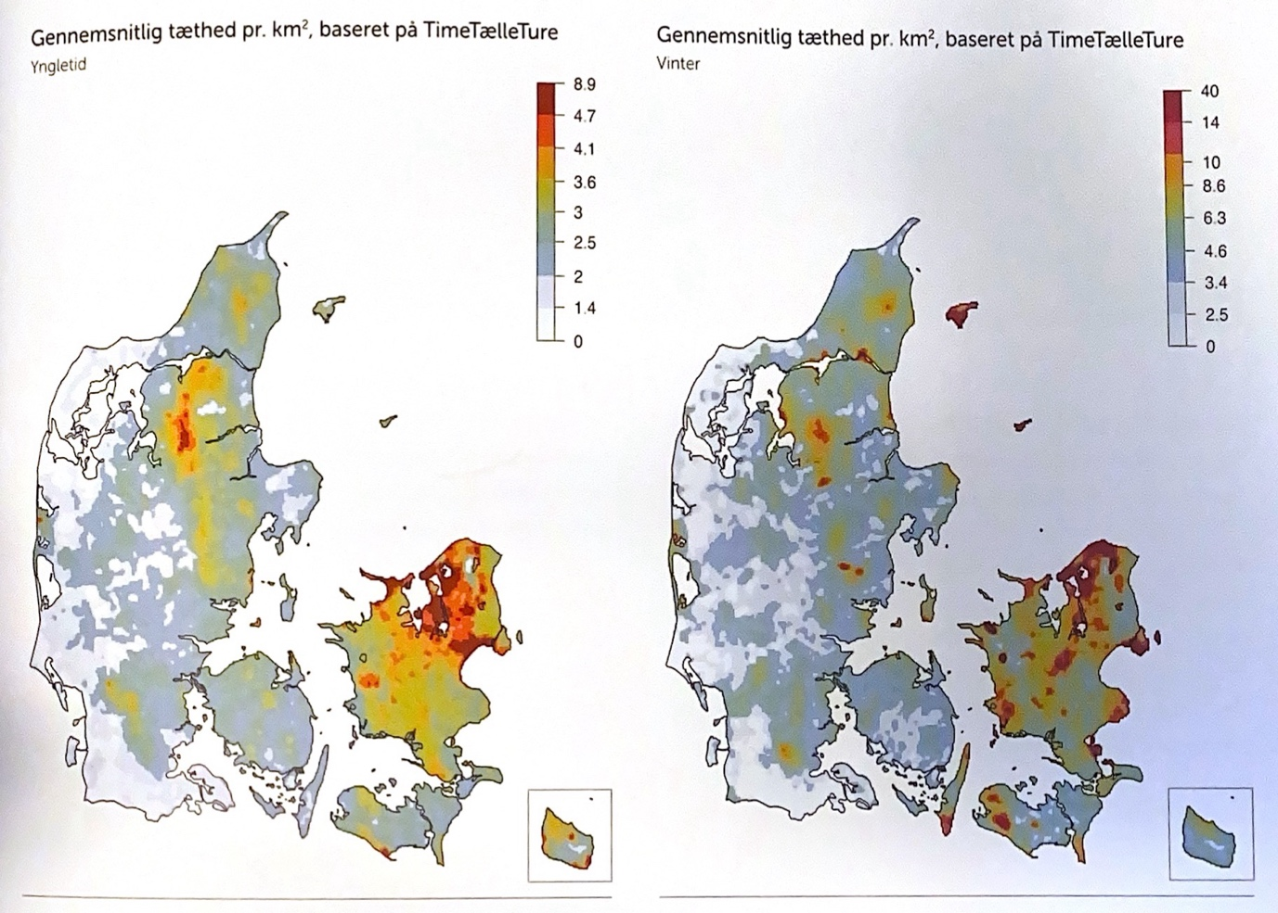

Fig 2: Density distribution of hooded crow in the breeding season (left) and winter (right)

**Nationwide population estimates pre-selected scarce species (spatial abundances)**

*Temporal*: 2014-2017

*Spatial*: Denmark, lattice *Resolution*: 5kmx5km

*Thematic*: preselected scarce breeding birds

*Data type*: nr of breeding pairs / cell (confirmed,probable,possible breeding)

|  |
| --- |
| **Species included:** |
| Eurasian bittern |
| Common teal |
| Corn crake |
| Common crane |
| Little ringed plover |
| Common sandpiper |
| European turtle dove |
| European night jar |
| Common kingfisher |
| Eurasian wryneck |
| Black woodpecker |
| Lesser spotted woodpecker |
| Grey wagtail |
| European stonechat |
| Firecrest |
| Eurasian penduline tit |
| European serin |
| Common rosefinch |

*Description:* The spatial distribution of population counts was estimated for 18 pre-selected scarce breeding birds. These species were selected based on the lack of knowledge about their distribution in Denmark.

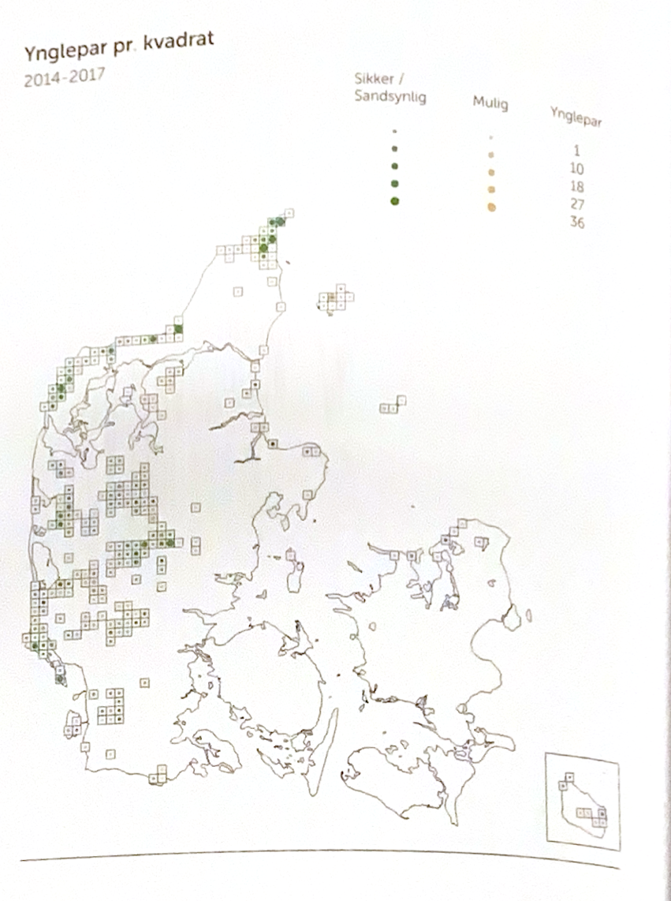

Fig 3: Number of breeding pairs (confirmed/probable, possible) per grid cell of the European nightjar

**Danish point count census (resurvey species counts)**

*Temporal*: 1976-2019 *Resolution:* yearly (breeding and winter)

*Spatial*: Denmark

*Resolution:* 50-400 routes distributed throughout the country

*Thematic:* breeding and wintering birds

*Data type*: spatiotemporal count data

*Description:* The Danish point count census has been ongoing for more than 40 years now. In this effort, volunteers visit the same *route* on a yearly basis, following an as consistent approach as possible (e.g. time of year, time of day and weather conditions). Each route consists of 10-20 points, each of which are observed for 5 minutes during a survey, by the same observer. Here, observations contain the number of each species seen or heard during the 5-minute point-count.

Additional information in the point counts include the weather conditions, as well as the habitat types the observation was made in (at least 1, up to 4 different types). The defined habitat types are coniferous forest, deciduous forest, arable land, bog/fen, heath, dune/beach, urban settlement, lake and meadow.

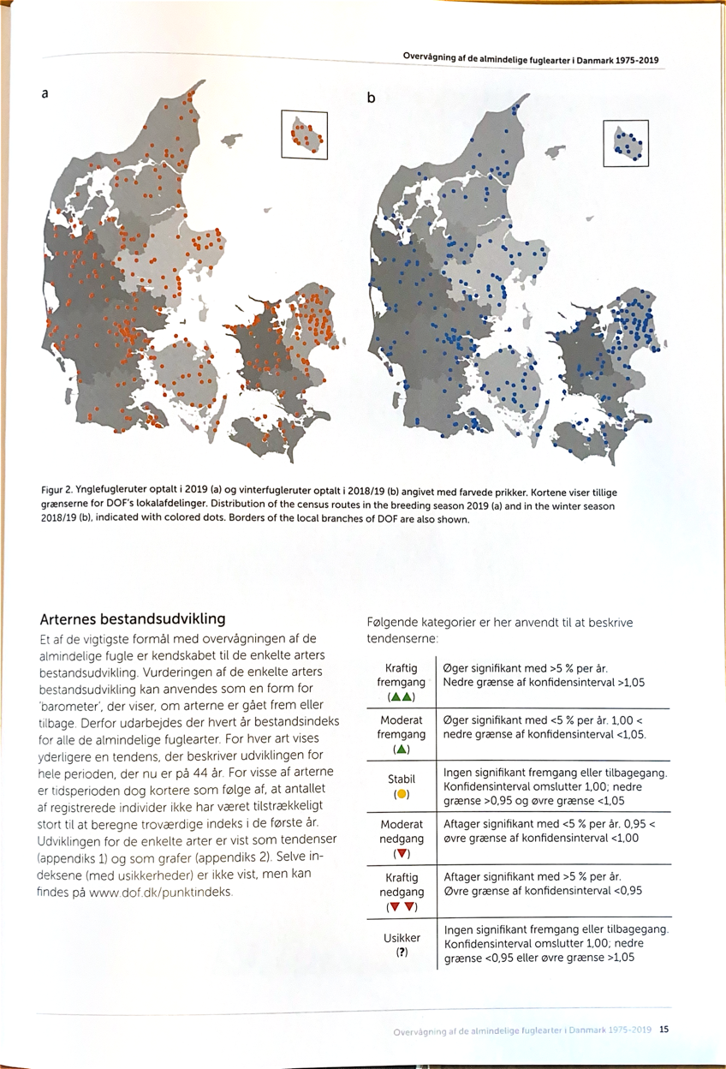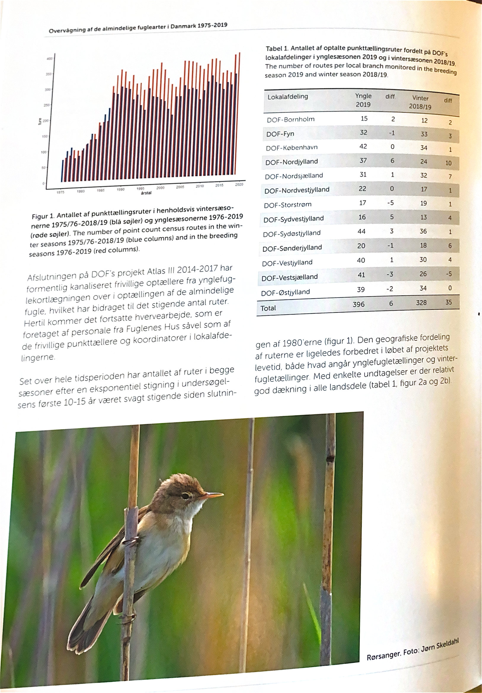

Fig 5: Spatial distribution of routes in 2019 (breeding, left) and 2018/2019 (winter, right).

Fig 4: Time series of number of routes surveyed each year in breeding (red) and winter (season). Y-axis ranges from 0 to 400

**Index trends breeding & wintering birds in Denmark**

*Temporal*: 1976-2023 *Resolution*: yearly (summer and/or winter)

*Thematic*: *Common* bird species across the country (summer and/or winter)

*Data type:* Indices (time-series of relative abundance)

*Description:* Indices indicate the relative changes in population size of ~170 species across Denmark. Indices are calculated using point count data using TRIM to account for uneven distributions in the landscape and temporal autocorrelation. Indices are calculated for individual species from the year in which they are registered on at least 30 active routes, hence the attribution of *common* in regards to thematic resolution of the data. The start year is further postponed if the first years have much greater variation than remaining years. The index is set to 100 in the first year, and future changes are calculated in relation to this base stock. An index of 200 thus indicates doubling of the stock, and index of 50 indicate halving. The method also calculates a standard error and 95% confidence interval.

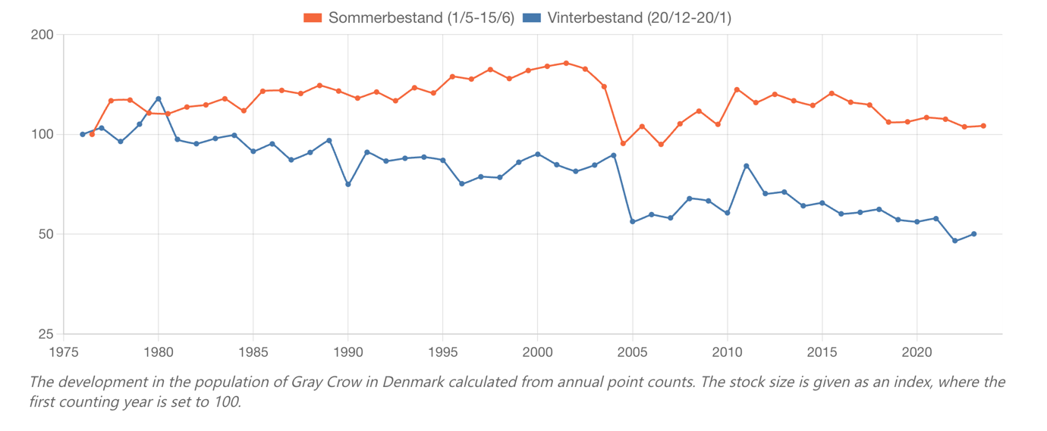

Fig 6: Indices of hooded crow in breeding (red) and winter (blue) seasons

**HILDA Historic reconstruction of European land use**

*Temporal*: 1900-2010 *Resolution:* 10yearly

*Extent*: Europe lattice *Resolution:* 1kmx1km

*Thematic:* 6 classes (urban, cropland, grassland, forest, water, other)

*Description:* The HILDA dataset describes historic land-cover changes in Europe (1900–2010) by integrating historic land-use datasets, remote sensing data, and regional records. Spatial allocation models distributed gross changes across the landscape at a 1 km resolution, accounting for biophysical and socio-economic constraints.



Fig 7: HILDA reconstruction of land use in Denmark in 2010